****

**END OF TERM ONE EXAMINATIONS 2023**

**MIDDLE CLASS**

**LANGUAGE DEVELOPMENT TWO**

NAME\_\_\_\_\_\_\_\_\_\_\_\_\_\_\_\_\_\_\_\_\_\_\_\_\_\_\_\_\_\_\_

1. **Circle the same sounds**.

a

n

n

p

s

a

s

t

a

p

c

p

t

i

i

1. **Fill in the missing sound “o”.**

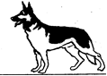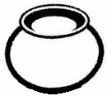

p\_\_\_\_\_t

b\_\_\_\_\_x

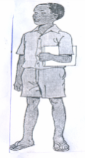

d\_\_\_\_\_g

b\_\_\_ok

b\_\_\_\_\_y

1. **Colour them**.

Yellow

Blue

1. **Sound these with actions**.

s a t i p n

1. **Match the same**.

star sun

set stone

snake star

sun set

stone snake

1. **Copy and draw**.

|  |  |  |  |
| --- | --- | --- | --- |
| https://encrypted-tbn1.gstatic.com/images?q=tbn:ANd9GcQhhFCVck52xUt7iZ4wD3napYhhp9Rn8957UXchsIzYDU7kz8lN0HNhEw |  |  | C:\Users\mitina\Desktop\IMG_0923.JPG |
|  |  |  |  |

1. **Match sound to picture**.

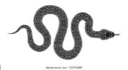

t

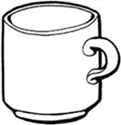

a

b

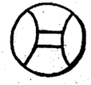

c

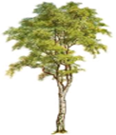e

s